**Walk 47 Walks around Luston Group Parishes 3**

Last walked in September 2018

Description. 8 km (5 miles). This walk takes us out of Luston village into the beautiful surrounding countryside. It is mainly thru fields, but with several stretches along quiet, minor lanes edged with wild flowers. It also takes us to the charming church of All Saints at Eyton (left).

Start. Balance Inn, Luston. Explorer Map 203 Grid 486633.

**Directions from Whitecross Roundabout** (Turn milometer to zero). Take the A4110 Canon Pyon (Three Elms road) for 1 mile and TR at the traffic lights onto the A4103 to Worcester (Roman road). TL at the first roundabout (2 miles), onto the A49 to Leominster. Go straight across the next two roundabouts (9.5 miles then 12.5 miles) on the A49 heading towards Shrewsbury. TL at the next roundabout (13.3 miles) onto the A44 to Leominster. At 13.8 miles TR onto the B4361 towards Richards Castle. At 15.8 miles you enter Luston, and at 16.4 miles you TL and park somewhere along Townsend Park road.

**1. Townsend Park.** Go back to the main road and TR. Walk up towards the Balance Inn (L), and just before the bus stop that’s across the road from the inn you TR and go thru a gate and along an enclosed track. Cross over three wood planks, a little further on the track bends R and continues on, there are fields on the L and buildings on the R. At the end of the enclosed track you continue on in the same direction (ignore the stile on your R), and go around the edge of a large field (**F1**) with a hedge on the R. At the end of **F1** you go thru a small metal gate into a narrow field (**F2**), and continue for a short distance along the R field edge to get to the end, where you TR and cross over a gated footbridge into **F3**. Bear half L, and about 60m across the field, at a hedge corner, you bear L and thru a k/gate and walk along an enclosed track until you reach a road, (Croft Lane) at the Riddle Common.

**2. The Riddle.** TL, walk a few paces then TR into Seggin Lane (Unsuitable for Heavy Goods Vehicles). Follow the lane for about 1¾ km, (the lane bends L a couple of times), to reach a T junction by Eyton Church. ***(Pause to enjoy this pretty church and its churchyard with lovely views. It is worth taking a short diversion by turning R and following the lane for 80m or so, to see Eyton Court, and a noted timber framed house on the R, and beyond it, Eyton Common. Return to the junction).***

**3. Eyton Church.** Cross the road in front and TR, walk a few paces then TL and go up the bank, thru a gate and along a short enclosed track and over a stile. Bear slightly L and cross a stile/gate in a wall and go into **F4**. Bear half L across the field to cross a footbridge into **F5**. Bear slightly R across **F5** to reach a gate between two oak trees. Go thru the gate into **F6** and follow the L field edge, keep the wood area on the L. Go over a stile/gate gap into **F7** and continue along L field edge, with the wood on your L. Go over a stile into **F8** and continue along L field edge to reach the wood end, (a small farm barn is on your left). Go thru a gate into **F9** and bear half R to pass an old willow tree and cross over stiles on both sides of a tarmac drive into **F10**. Cross over this field and climb over another stile and wooden planks into **F11**. ***To the left is Scatterbrain Farm, its name recalls carnage in this vicinity during the Wars of the Roses.*** Cross this field, pass a power line pole that’s in the middle of the field to go thru a hedge gap that’s just to the L of twin power line poles into **F12**.

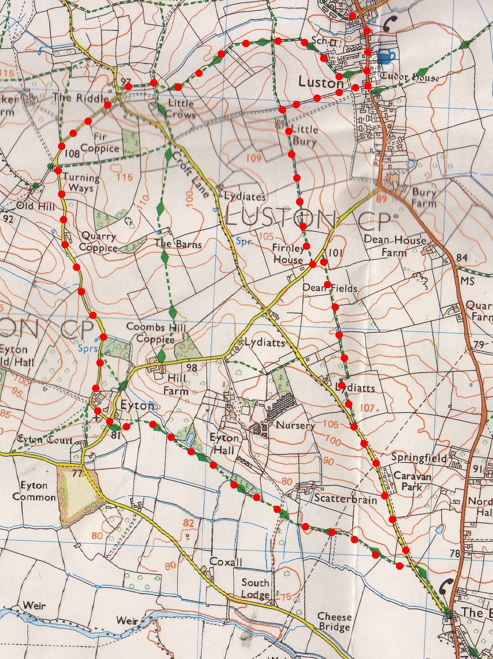Keep to the hedge that’s on your L, and when it turns sharp L, by a Byway marker, you continue straight on across the field, to go thru a k/gate in the hedge ahead into Croft Lane and TL.

**1**

**4. Croft Lane.** Walk on up the road for about ¾ km, passing a Children Playing signpost that’s by a small static caravan site. Just before you reach the brow of the hill you TR thru a kissing gate and into **F13**. Walk on a few paces keeping to the hedge on your left. ***Pause then to enjoy panoramic views over Luston, Eye Church, Eye Manor and Berrington Hall, and beyond to Titterstone Clee and Brown Clee.*** At the hedge corner you TL and follow the hedge to the end of the field, bearing slightly R to go thru a small metal gate by a willow tree into **F14**. Continue down the L field edge to cross a stile and two wood planks into **F15**. Continue up the L field edge and over the next stile into **F16**. Continue along hedge and when it ends, head straight across the field to get to the top corner.

**5**

**2**

**5. Tarmac Lane.** Cross a stile/metal gate onto a tarmac lane and TL. Walk about 80m and just before the house you TR and go thru a gate gap into **F17**]. Go straight across the field to reach a copse, ***a nature reserve***, and continue on to reach a stile in the field corner. TR, cross the stile and continue along a short enclosed fenced path (copse on the R). At the end you TL over a stile into **F18** and continue along the R field edge. Go thru a gate gap in the corner into **F19**, continue along R field edge. Go thru small metal gate into **F20** and continue down the R field edge. TR thru small metal gate into **F21**, continue along L field edge for a short distance to reach a farm track/drive that by a cattle grid. TR and follow the drive back to the village, passing a chapel on the R. At the road junction you TL and return to Townsend Park Road on the L and to the car.

**3**

**4**